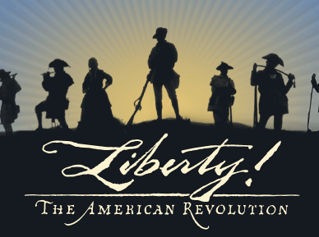

Battle of Alamance
The 244th Anniversary of the Battle of Alamance Event Agenda
Events Sunday May 17th, 2015 (free admissions)
5803 South N.C. 62 Burlington, N.C. 27215
Please sign in as a Long Family Member
We have been asked to register the Descendants of the Longs in the guest book because of our family link to the patriots that fought at the site.
10:00 - Battleground opens
10:30 - Militia surgeon talk
11:00 - A conversation with Regulator, Rednap Howell
12:00 - Divine service
1:00 - Artillery demonstration
1:30 - Musket at 1:30
2:00 - A conversation with Governor Tryon
2:30 - Special showing of the new "Regulator' documentary
2:30 - There will be additional living history presentations near the historic house, and more
musket and artillery demonstrations
4:00 - Battleground closes

Lisa Cox
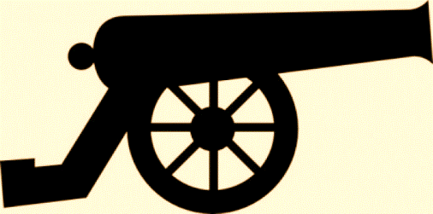
Historic Site Assistant, Alamance Battleground
NC Department of Cultural Resources
Division of State Historic Sites & Properties
5803 South N.C. 62
Burlington, N.C. 27215
Ph. (336) 227-4785 / Fax. (336) 227-4787
E-mail: lisa.d.cox@ncdcr.gov

