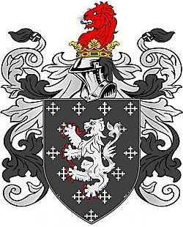
The Long Family Origins
The ancient name Long is a Norman name that would have been developed in England after the Norman Conquest of England in 1066. This name was a name given to a person who was tall, big or lanky.

The English Long family is descended from a Norman noble Preux in Normandy. The family name Long became popular in England after the Norman Conquest when William the Conqueror gave his friends and relatives most of the lands formerly owned by Anglo-Saxon aristocrats.

The Long Family was first found in Wiltshire where they held a family Seat from early times and their first records appear on the early census rolls taken by the early Kings of Britain to determine the rate of taxation of their subjects.

The Long family of New Hope, Orange County, North Carolina came to North Carolina with a group of other Scot-Irish families. They were considered Ulster Scots and migrated first to Holland, then Ireland across the Atlantic to Lancaster, Pennsylvania and finally settled in 1750.

The Family Crest Motto is a War Cry and Slogan,
Pieux Quoique Preux, meaning “Pious although Chivalrous”

